Дополнительные материалы к уроку Unit 2/Lesson3/ Washington, D.C
Предлагаю Вашему вниманию свою собственную разработку системы упражнений для создания полноценного урока с применением технологии CLIL (интеграция истории США и английского по теме Вашингтон, столица США). Рекомендую дополнить предложенные упражнения текстом из урока 3 в учебнике(после работы с видео).
1. Here are some important dates from the history of the USA. Do you know what happened in those years? Match the years and the events.
The declaration of Independence was signed.
1607
American Revolution (The Independence war)
1775-1783
American Civil War (North vs South war)
1776
The last state joined the federation (the USA)
1789
The 1st President of the country was chosen.
The beginning of British colonization (the first British colonists came to the northern coast of the country)
1861-1865
1862
The emancipation proclamation (the end of slavery)
1867
The USA bought Alaska from Russia
1959
2. Here you can see the names of some important people connected with the history of the USA. What do you know about them?
Christopher Columbus ________________________________________________________________________
George Washington __________________________________________________________________________
Thomas Jefferson ____________________________________________________________________________
John Adams _________________________________________________________________________________
Abraham Lincoln _____________________________________________________________________________
3. Watch the 1st part of the documentary and mark the statements TRUE, FALSE or NOT STATED.
1) Different cities wanted to be the capital of the country.
2) The city of Washington was a small provincial town before 1791.
3) The city was named after the 1st president of the USA.
4) It was a French architect who planned the city.
5) There are a lot of monuments of great statesmen in the city.
6) The second president and the government moved to Washington at the beginning of the 19th century.
7) Washington is an industrial city.
8) No building in the city can be higher than 400m.
9) The Washington monument is the highest building in the city.
4. Watch the second part of the video. Complete the sentences with words and phrases from the video.

1) The National Mall is ________________ green street.
2) You can do ______________________on the Mall.
3) Begin your tour on the Mall at _______________________________________.
4) America’s most famous residence is ___________________________________.
5) The Washington monument is ________________ high and is made of ________________.
6) ____________________ is the seat of the federal government.
7)
8) Admire _____________________________________ at the Franklin Delano Roosevelt memorial.
9) Thomas Jefferson memorial was built in the style of _________________________________.
10) The Smithsonian Institution building is called _______________________.
11) The whole family will enjoy The Smithsonian __________________________________museum.
12) _______________________of the Capitol building offers an escape from monuments and museums.
13) You can use ________________________system to explore the attractions outside the Mall.
14) The ____________ bottom suburb was named after the___________ that rises from the Potomac River.

5. What landmarks can you see in the pictures?

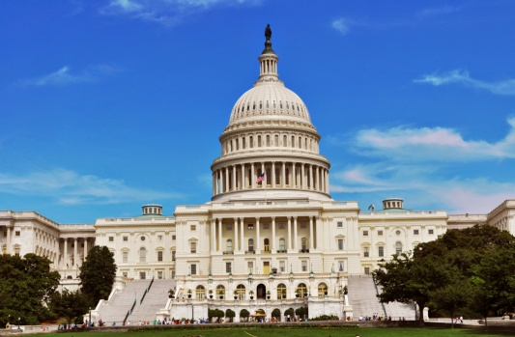
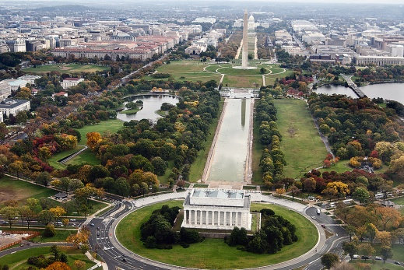
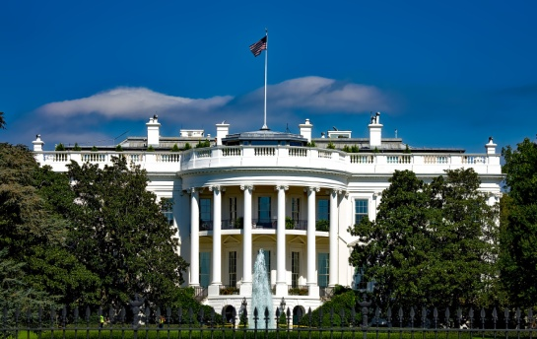

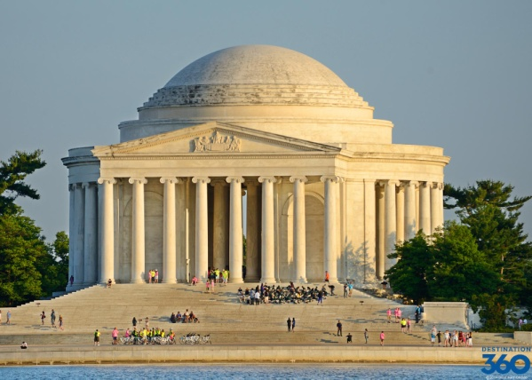
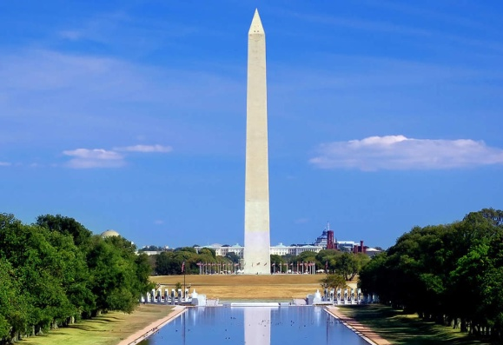
1 2 3
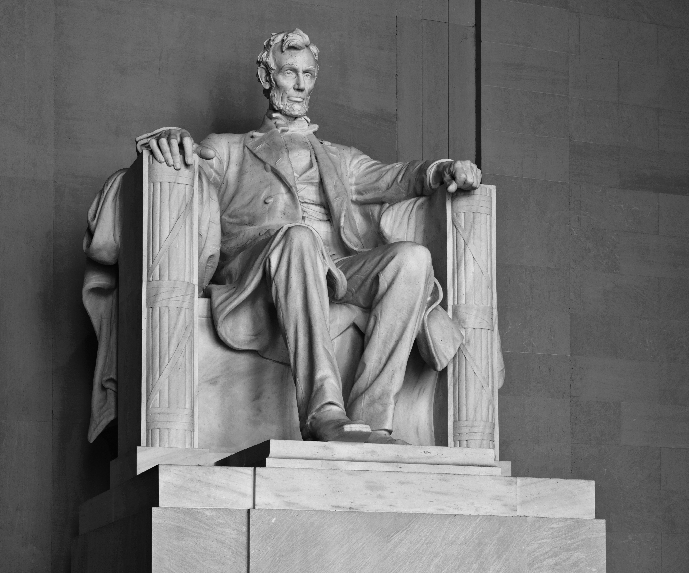
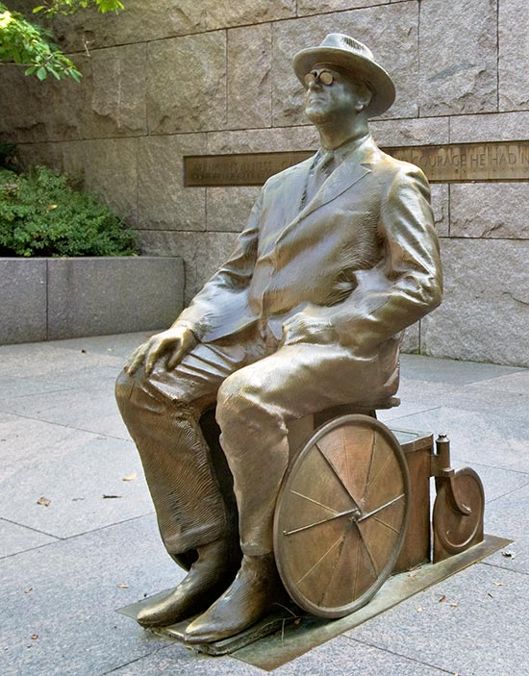

4 5

6 7

